DATA ANALYTICS ASSIGNMENT 3

**Name :- Patrurla Prasanth**

**Roll no :- 20PC1A0516**

**College:- Vizag institute of technology**

**Track :- Data analytics with tablesu**

**DATASET :** [**Sample - Superstore.xls**](https://docs.google.com/spreadsheets/d/1Vmsk3xJ_qp69U0AZzCpNybqX0AP4KSon/edit#gid%3D972120833)



* **Define at least two sets based on specific criteria from your dataset (e.g., high-value customers, top-performing products).**
* **Experiment with combining sets using UNION, INTERSECT, and MINUS operations.**
* **Create 2 Calculation field using any aggregate function**
* **Create any 3 visualization using quick Table Calculations**

**HIGH-VALUE CUSTOMERS BY SALES**

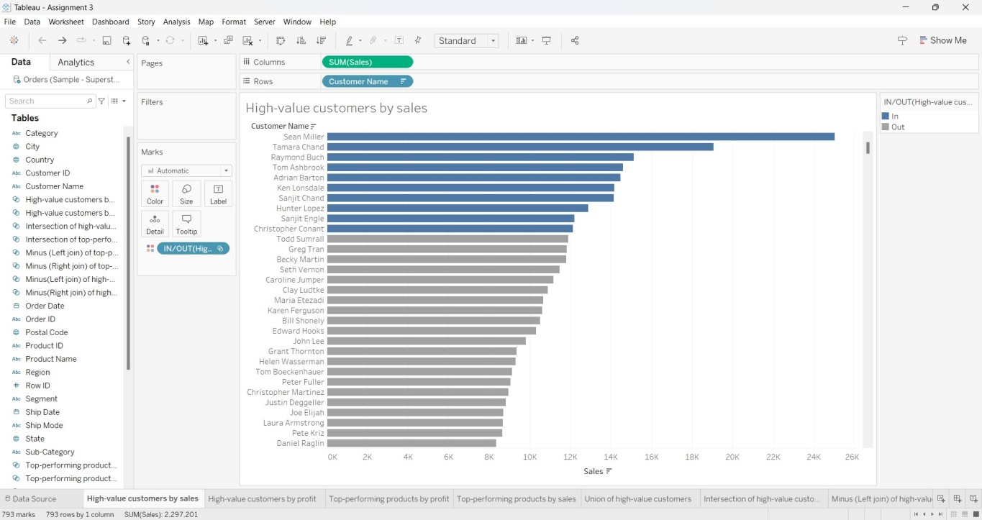

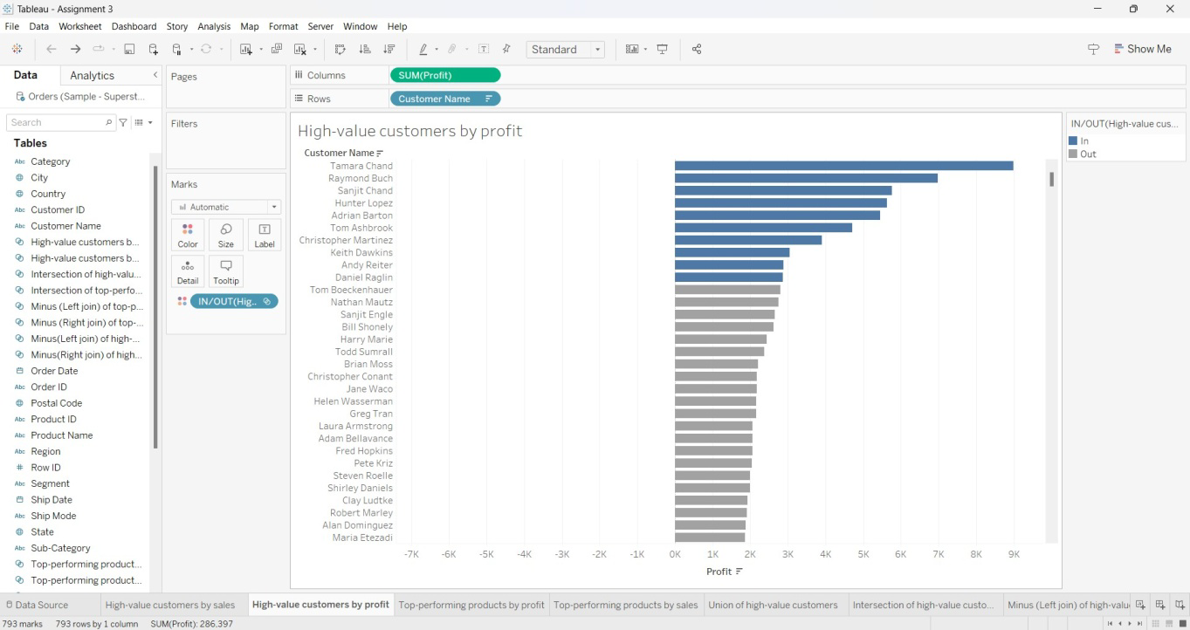

**UNION OF HIGH-VALUE CUSTOMERS**

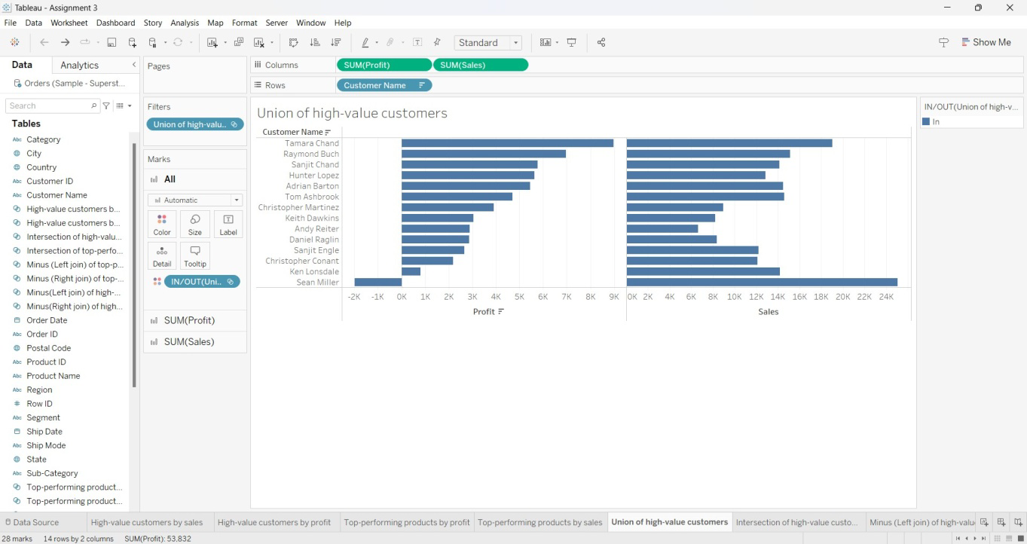

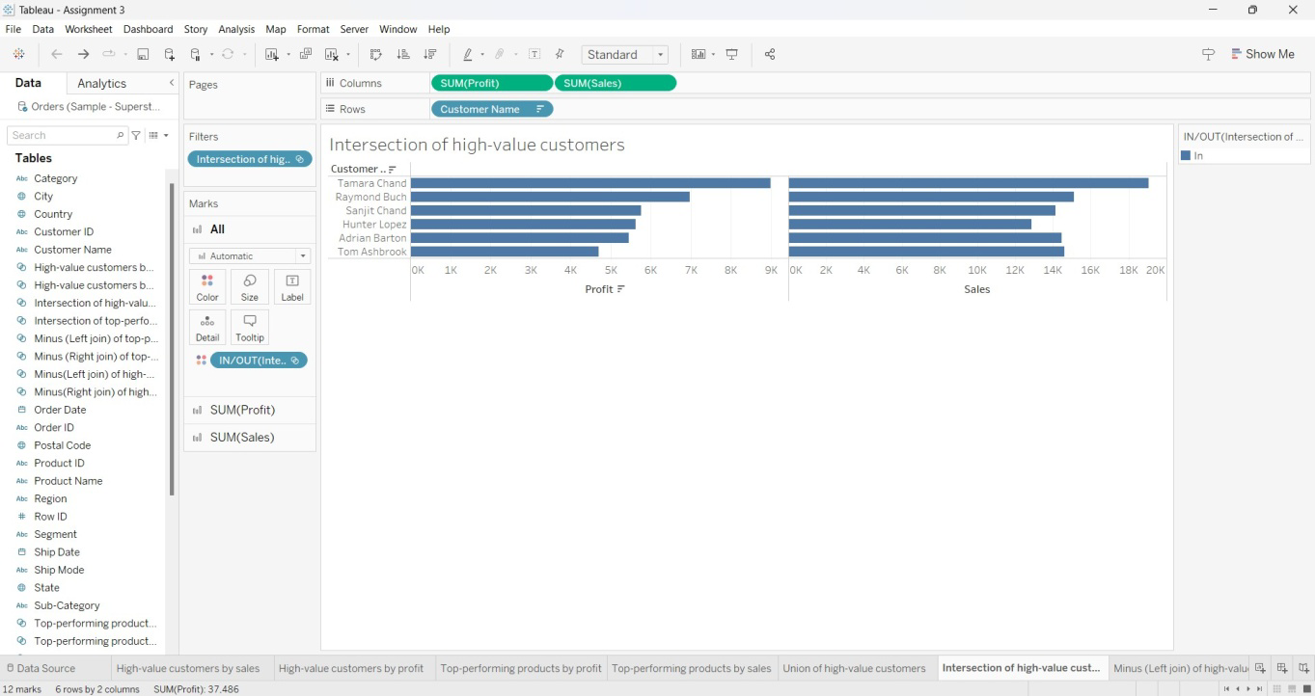

**MINUS (LEFT JOIN) OF HIGH-VALUE CUSTOMERS**

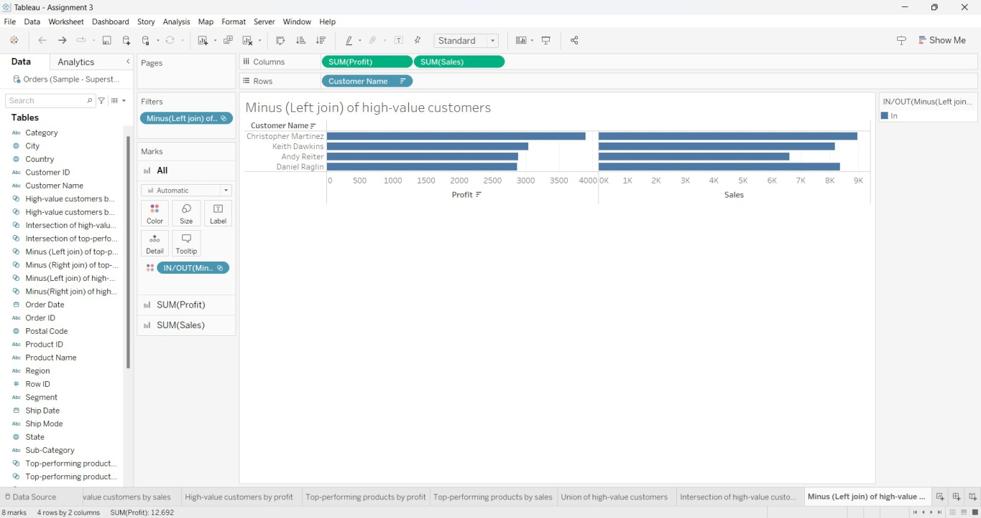

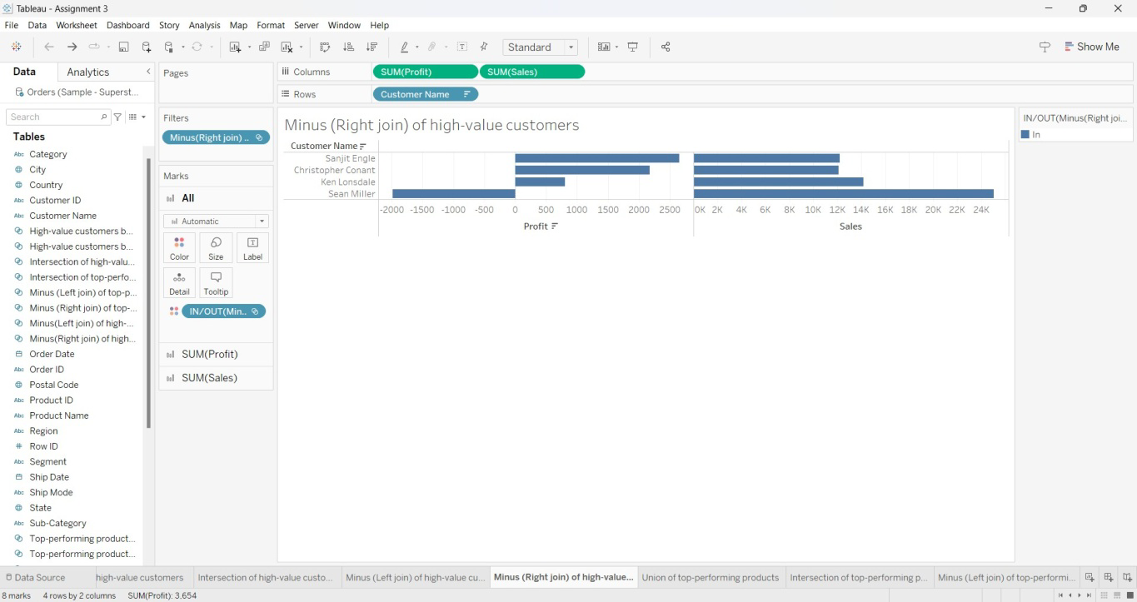

**TOP-PERFORMING PRODUCTS BY PROFIT**

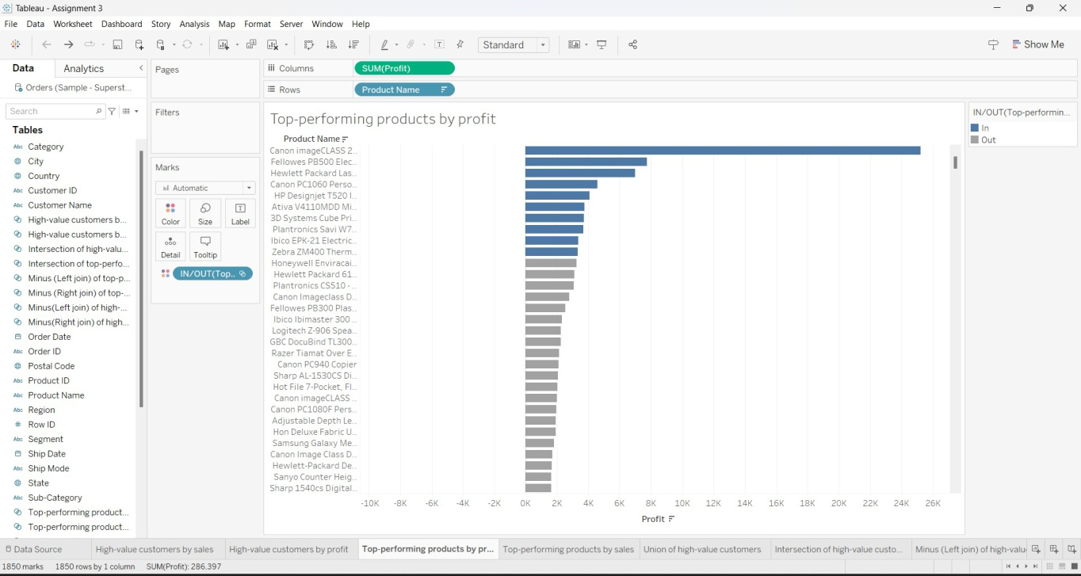

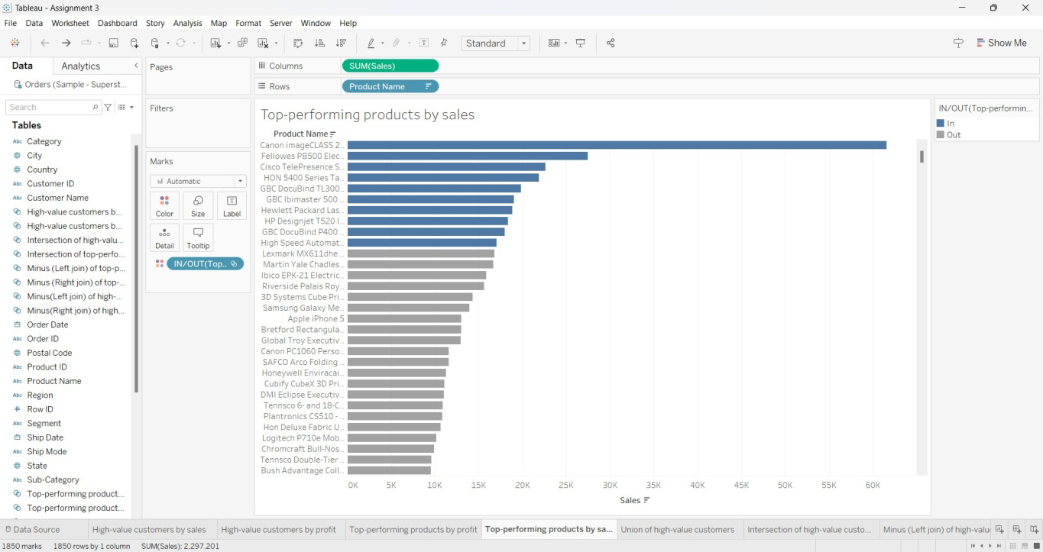

**UNION OF TOP-PERFORMING PRODUCTS**

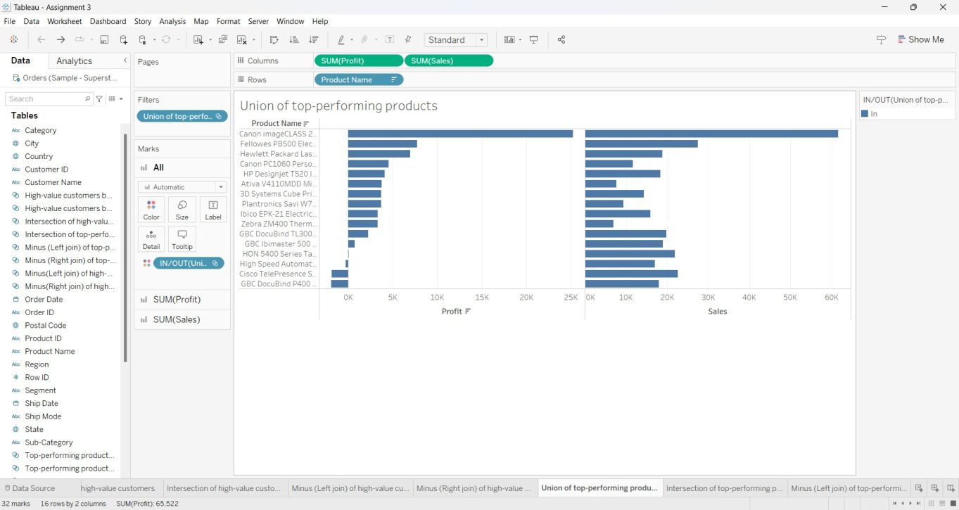

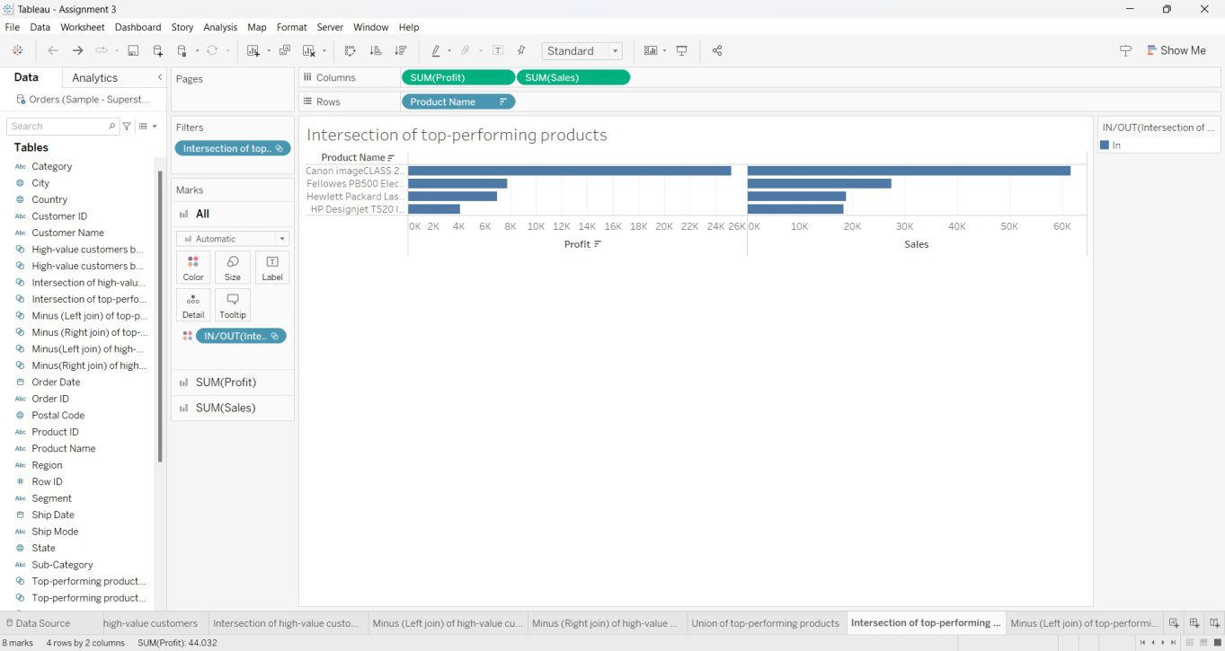

**MINUS (LEFT JOIN) OF TOP-PERFORMING PRODUCTS**

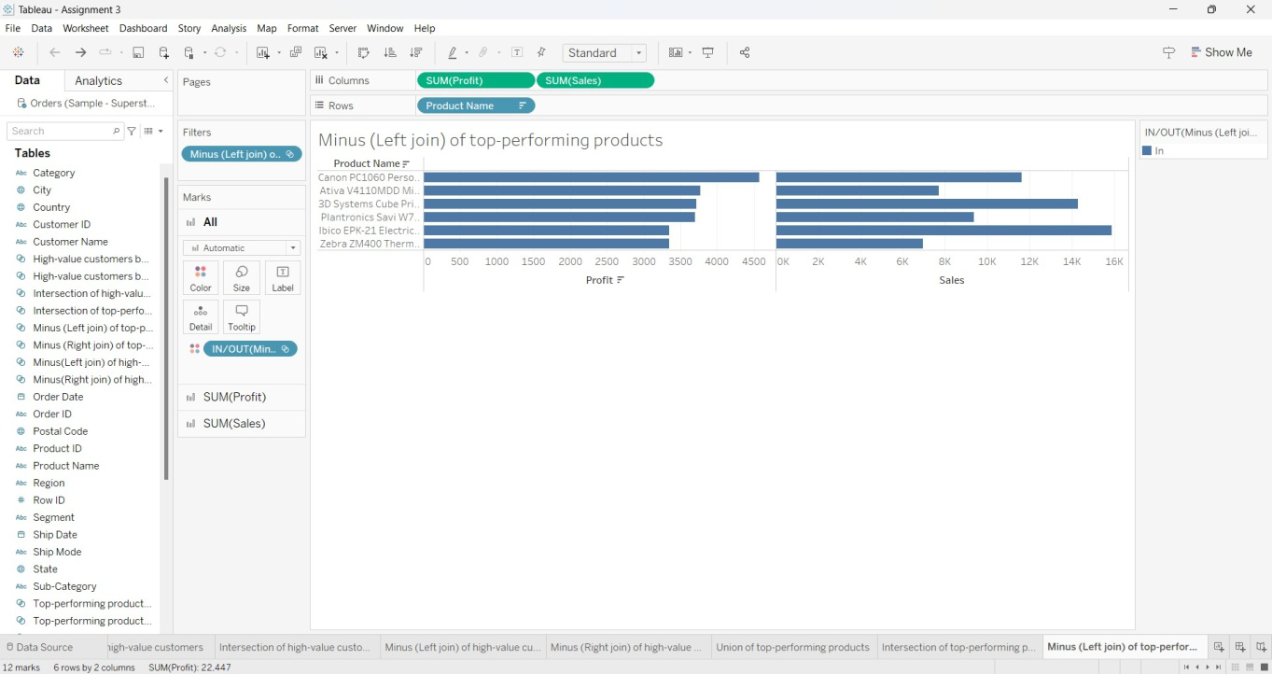

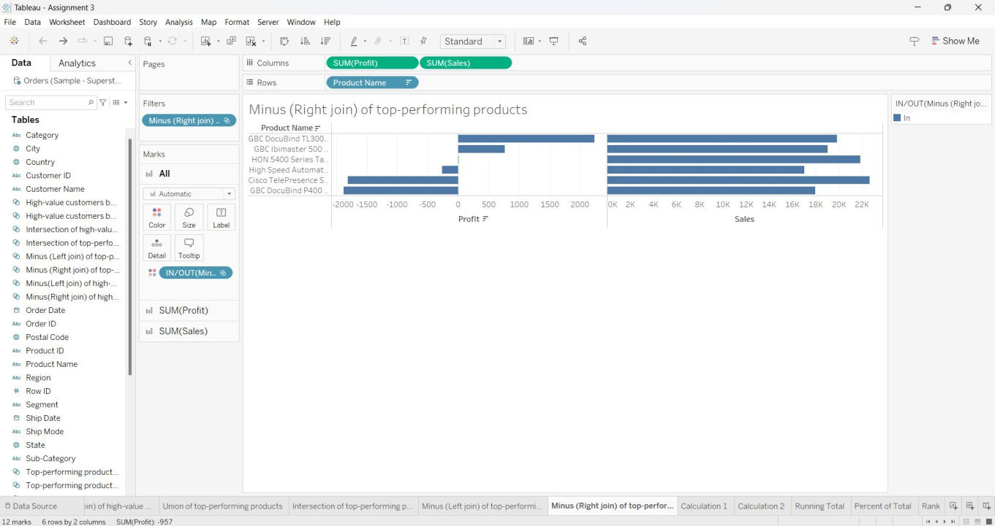

**CALCULATED FIELD - 1**

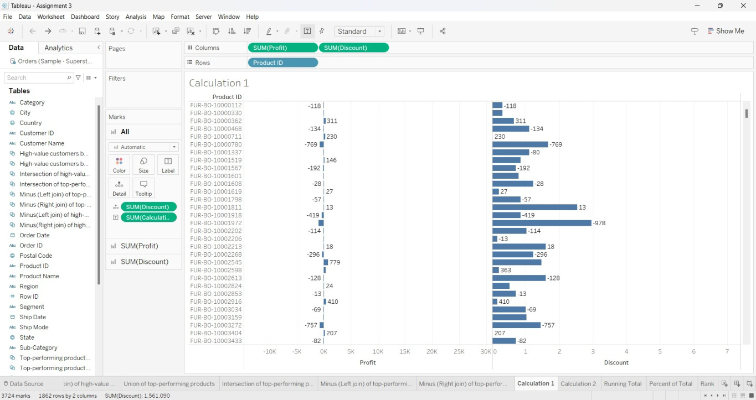

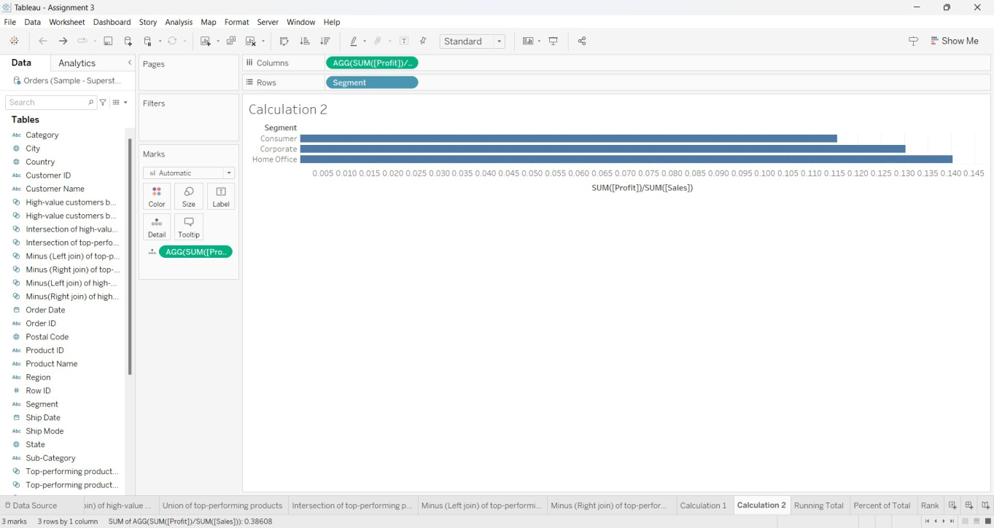

**QUICK TABLE CALCULATIONS: RUNNING TOTAL**

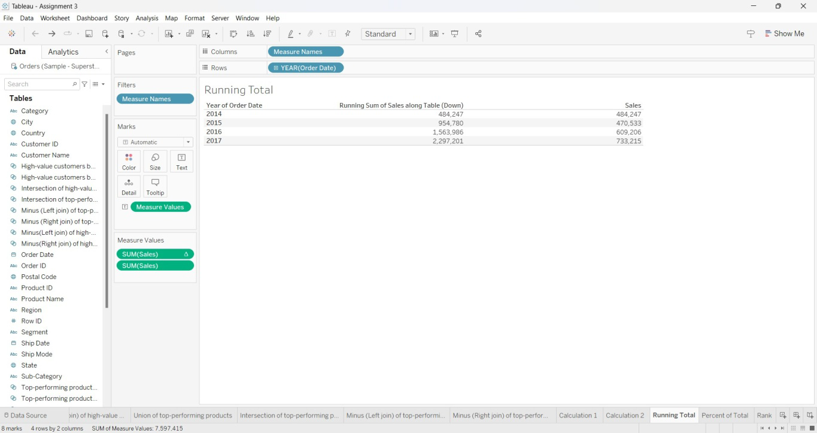

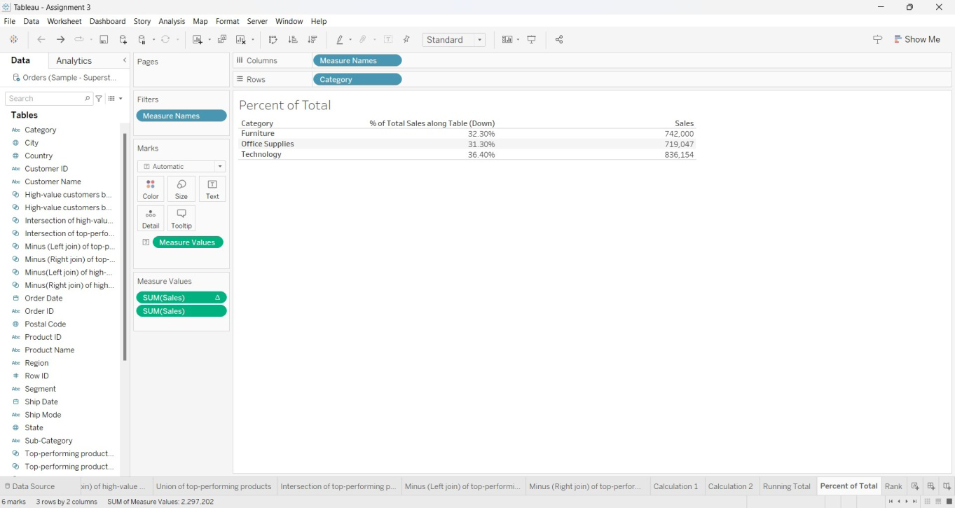

**RANK**

